CS 255 System Design Document Template

UML Diagrams

UML Use Case Diagram
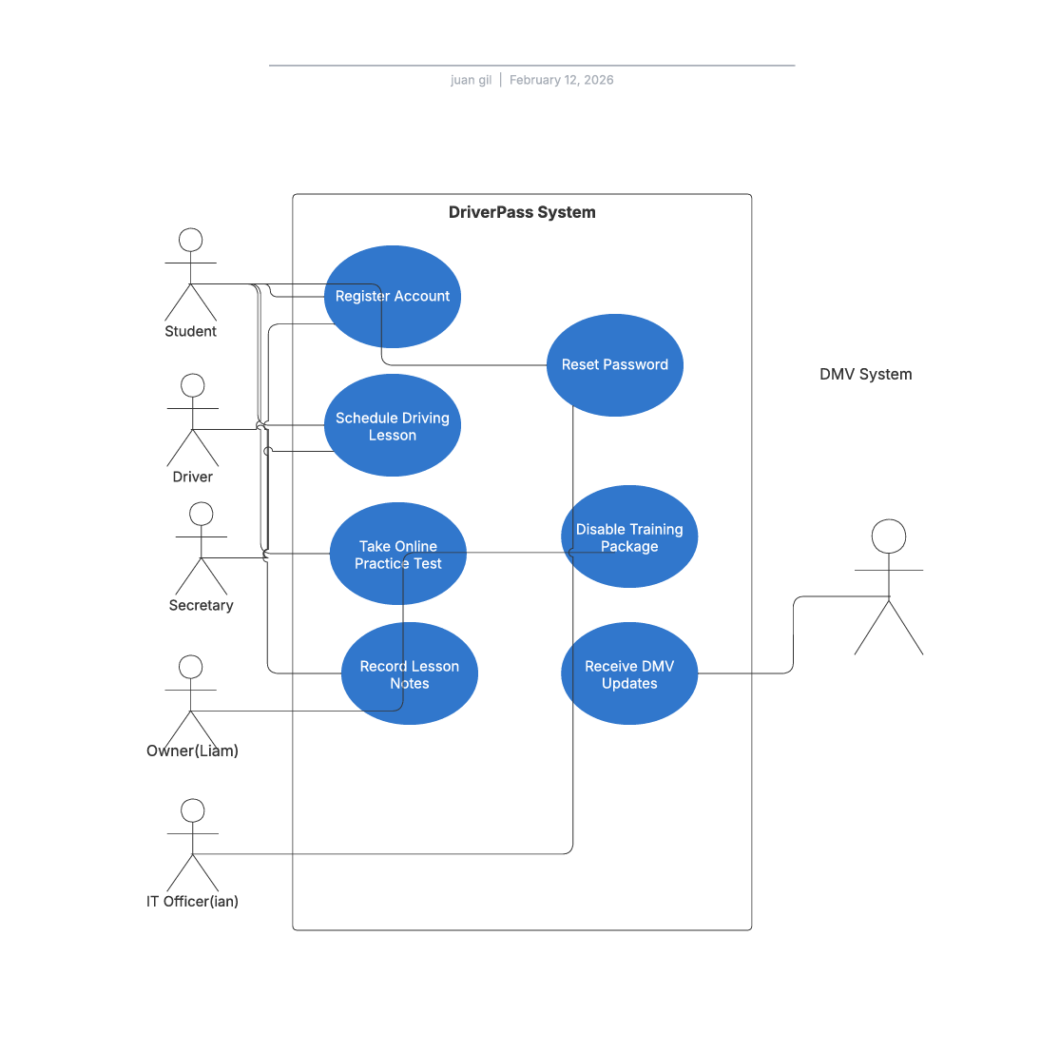

UML Activity Diagrams
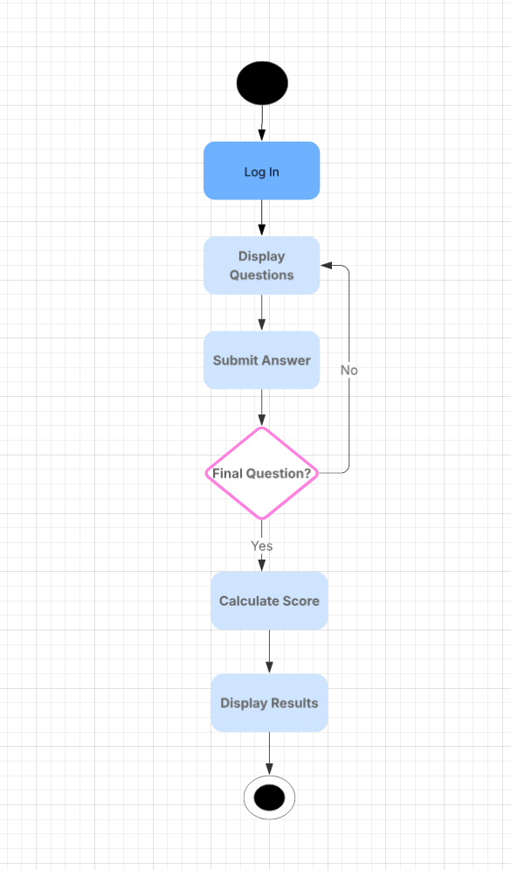
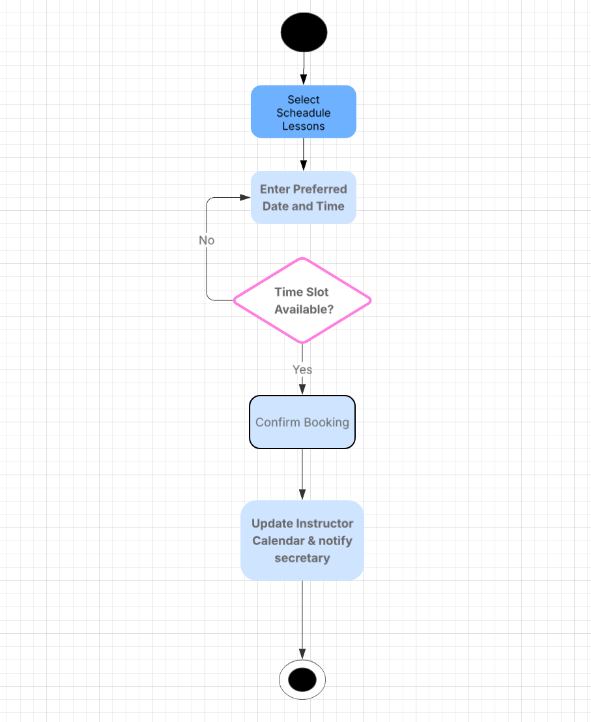
Case diagram 1
case diagram 2

UML Sequence Diagram
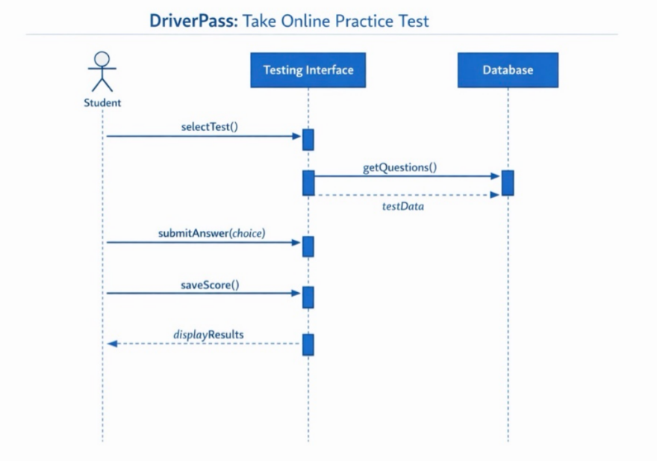

UML Class Diagram
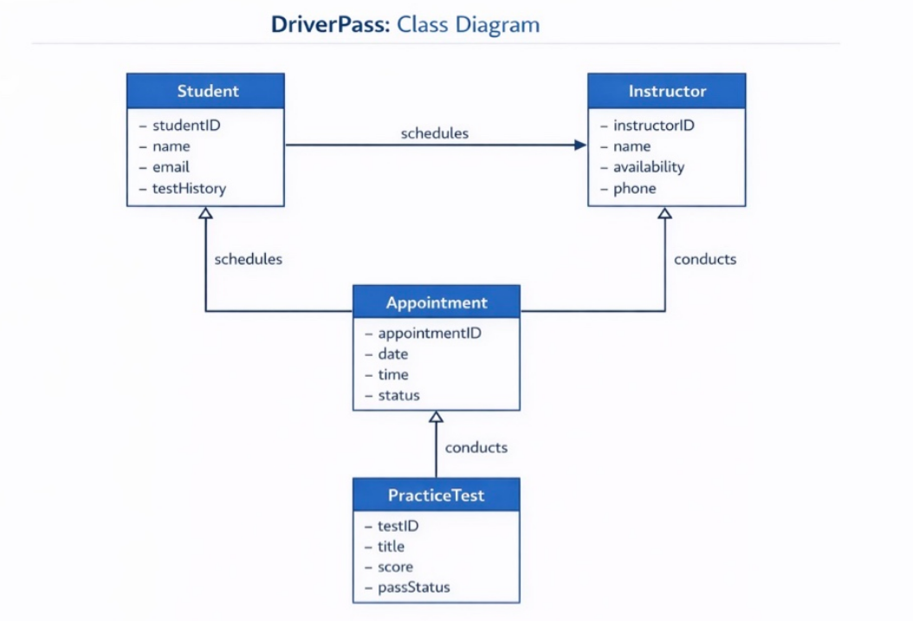

Technical Requirements

Hardware
- Cloud Hosting Servers: To ensure the DriverPass system is available 24/7 for students to take practice tests, we will utilize high-availability cloud servers (such as Amazon Web Services or Microsoft Azure).
- Instructor Tablets: As seen in the "Schedule Driving Lesson" activity diagram, instructors need to receive real-time updates; therefore, staff will be equipped with LTE-enabled tablets to record lesson notes and update their availability while in the field.
- Client Devices: The system will be optimized for standard consumer hardware, including laptops, desktops, and smartphones, allowing students to access the Testing Interface from any modern browser.

Software
- Relational Database Management System (RDBMS): We will implement a SQL-based database (such as PostgreSQL) to manage the complex relationships defined in our Class Diagram, specifically ensuring that StudentIDs are accurately linked to Appointment records and TestHistory.
- Application Framework: The system will be built using a responsive web framework (like React.js for the front-end and Node.js for the back-end) to provide the seamless interaction shown in the Sequence Diagram between the Student and the Testing Interface.
- Operating Systems: The server environment will utilize a Linux-based OS (like Ubuntu Server) for its stability and security, while the client-side application will remain platform-independent via web browser access.

Tools
- CASE Tool: Lucidchart was utilized as the primary Computer-Aided Software Engineering (CASE) tool to create the UML models, ensuring that the system architecture is visually mapped and logically sound before development begins.
- Version Control: We will use Git and GitHub to manage the codebase, allowing multiple developers to work on the system components (Testing, Scheduling, and Admin) simultaneously without data loss.

Infrastructure
- Network and Connectivity: High-speed internet connectivity is required for the centralized database to process the getQuestions() and saveScore() calls depicted in our Sequence Diagram.
- Security Protocols: To meet the client's need for data privacy, we will implement SSL/TLS encryption (HTTPS) for all web traffic and a robust firewall to protect the Database from unauthorized external access.
- Automated Backup System: A daily automated backup infrastructure will be established to prevent the loss of critical student progress data and instructor schedules.

